**Assignment 9**

**Aim:** Convert a raster map to a vector layer and a vector layer to a raster using QGIS.

### Understanding Raster to Vector Conversion

#### What is Raster Data?

Raster data is a way of representing geographic information using a grid of pixels. Each pixel holds a specific value that defines a particular attribute of the area it represents.

#### What is Vectorization?

Vectorization is the process of transforming raster data into vector data. Unlike raster data, vector data represents geographic features using points, lines, and polygons.

#### Tools in QGIS for Raster-to-Vector Conversion

QGIS provides multiple tools for converting raster data into vector format, including:

* **Raster to Vector (GDAL)** – Uses the Geospatial Data Abstraction Library (GDAL) to convert raster data into vector format.
* **Polygonize (GDAL)** – Converts raster data into polygon features.
* **Lines to Polygons** – Converts line features into polygon features.

#### Steps to Convert Raster to Vector in QGIS

1. Open QGIS and load the raster layer.
2. Navigate to **Raster > Conversion > Raster to Vector (GDAL).**
3. Select the input raster layer and specify the output vector format (e.g., Shapefile, GeoJSON).
4. Click **Run** to execute the conversion.

### Understanding Vector to Raster Conversion

#### What is Vector Data?

Vector data is used to represent geographic features such as points, lines, and polygons. It provides precise details about locations and boundaries.

#### What is Rasterization?

Rasterization is the process of converting vector data into raster format. In this process, vector features are mapped onto a grid of pixels, where each pixel is assigned a specific value.

#### Tools in QGIS for Vector-to-Raster Conversion

QGIS offers several tools to perform this conversion, including:

* **Vector to Raster (GDAL)** – Uses GDAL to transform vector data into raster format.
* **Polygon to Raster** – Converts polygon features into raster data.

#### Steps to Convert Vector to Raster in QGIS

1. Open QGIS and load the vector layer.
2. Navigate to **Vector > Data Management Tools > Vector to Raster (GDAL).**
3. Select the input vector layer and specify the output raster format (e.g., GeoTIFF, JPEG).
4. Adjust the resolution and extent as needed.
5. Click **Run** to complete the conversion.

**Result:**

Step 1: open QGIS

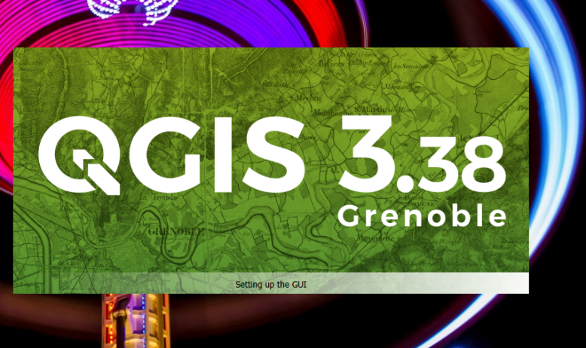

Step 2: select add layer and raster layer

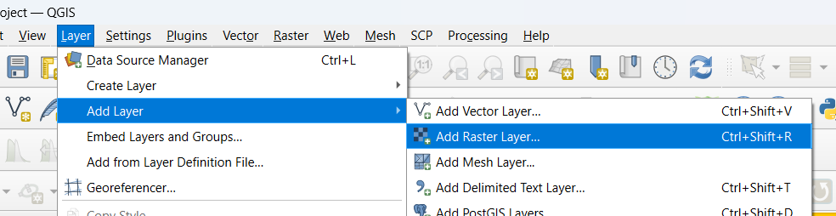

Step 3: select the raster data and add Raster data

|  |  |
| --- | --- |
|  |  |

|  |  |
| --- | --- |
| Step 4: open raster file | Step 5 select the conversion and raster to vector |

|  |  |  |
| --- | --- | --- |
| Step 6: convert the raster data into vector | Step 7: result after converting raster file into vector | |
| Step 8: convert the vector file into raster | | Step 9: give the values for raster conversion |
| Step 10: result after converting vector image into raster | | Step 11: final result of raster to vector |

step 12: final result of vector to raster

